1. Interactivity with Text and Visual Tooltips
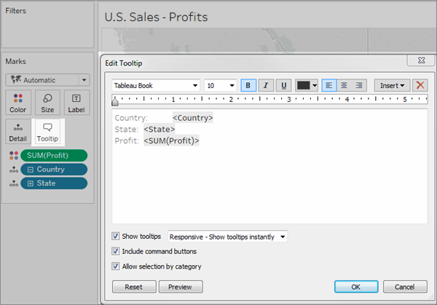
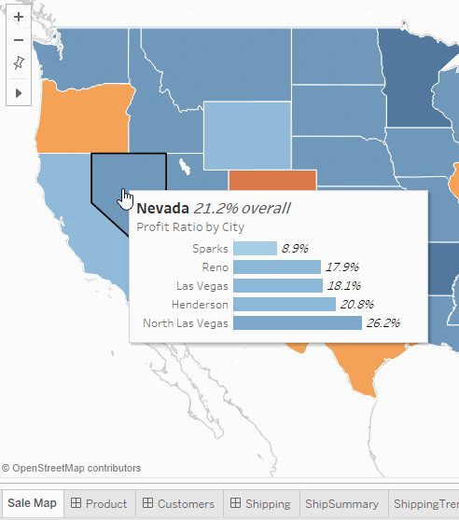
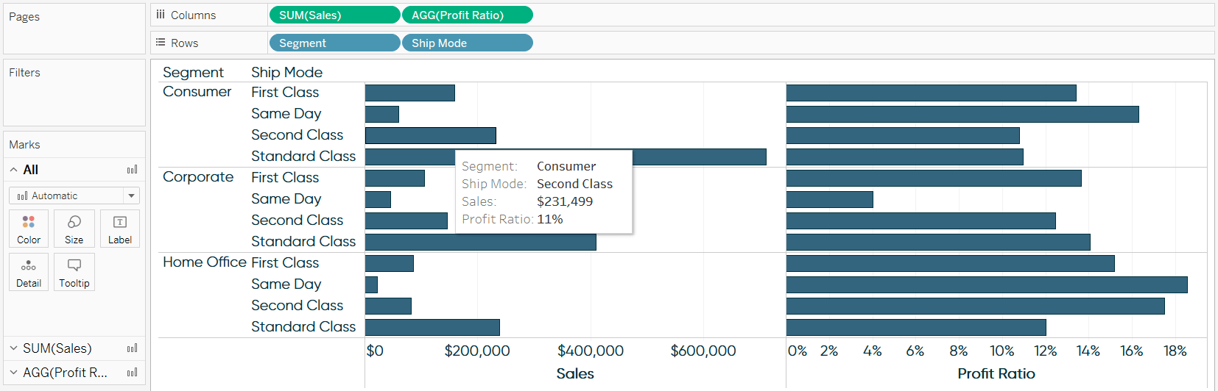
4
A. Text Tooltips
Tooltips appear when you hover over a bar, point, or line.
Steps
- Create any chart (bar, line, scatter).
- Go to the left panel and click Tooltip in the Marks section.
- A tooltip editor window opens.
- Write text or insert fields using the Insert dropdown.
- Click OK to apply.
- Hover on your chart to test.
Tip:
Avoid long paragraphs. Show important information like value, category, percentage.

B. Visual Tooltips
You can add charts inside tooltips.
Example
Show monthly trend when hovering over a category bar.
Steps
- Create a small chart on a separate sheet (like Sales by Month).
- Go back to main chart.
- Open Tooltip editor.
- Click Insert → Sheets → [Your sheet name].
- Adjust size and formatting.
- Hover to preview.
This gives a mini dashboard effect without leaving the view.

2. Interactivity with Actions
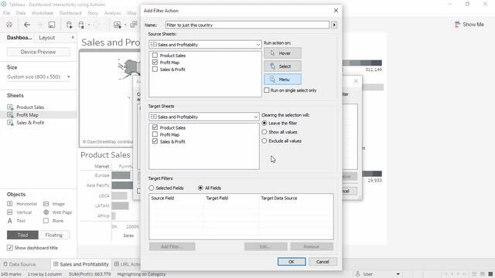
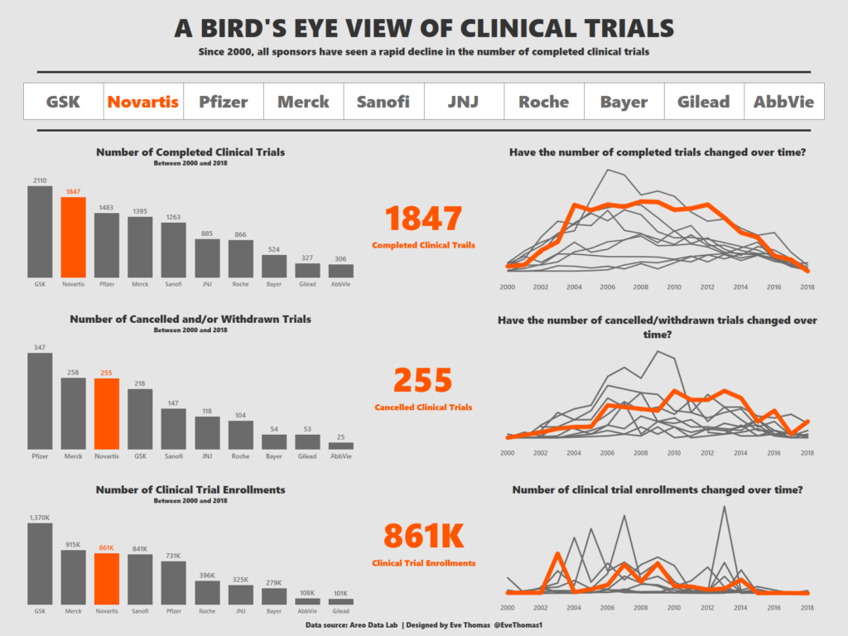
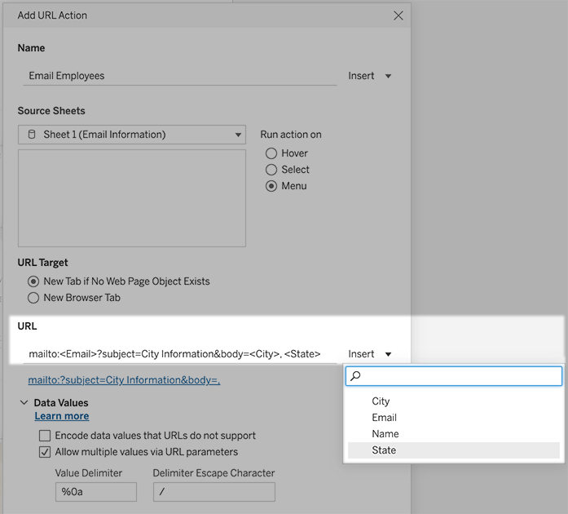
4
Tableau actions connect sheets or dashboards so that user clicks trigger a response.

A. Filter Action
Click one chart to filter another.
Steps
- Open your dashboard.
- Go to menu: Dashboard → Actions.
- Click Add Action → Filter.
- Choose Source Sheet (where user clicks).
- Choose Target Sheet (what will be filtered).
- Select Run action on: Select.
- Test by clicking categories or regions.
Result: Clicking one bar filters other visuals.

B. Highlight Action
Emphasizes data without filtering.
Steps
- Open dashboard.
- Go to Dashboard → Actions → Add Action → Highlight.
- Select source and target sheets.
- Choose field to highlight (Category, Region, etc.).
- Use Run on Hover for fast interaction.
Result: Items glow while non-related items fade.

C. URL Action
Open external pages for more context.
Example
Click a product name and Google search it.
Steps
- Dashboard → Actions → Add Action → URL.
- Choose Source Sheet.
- In URL box type:
- https://www.google.com/search?q=<Product Name>
Replace <Product Name> using Insert Field.
- Choose Run action on: Select.
Result: Clicking opens browser with product search.

3. Drilldown Between Dashboards
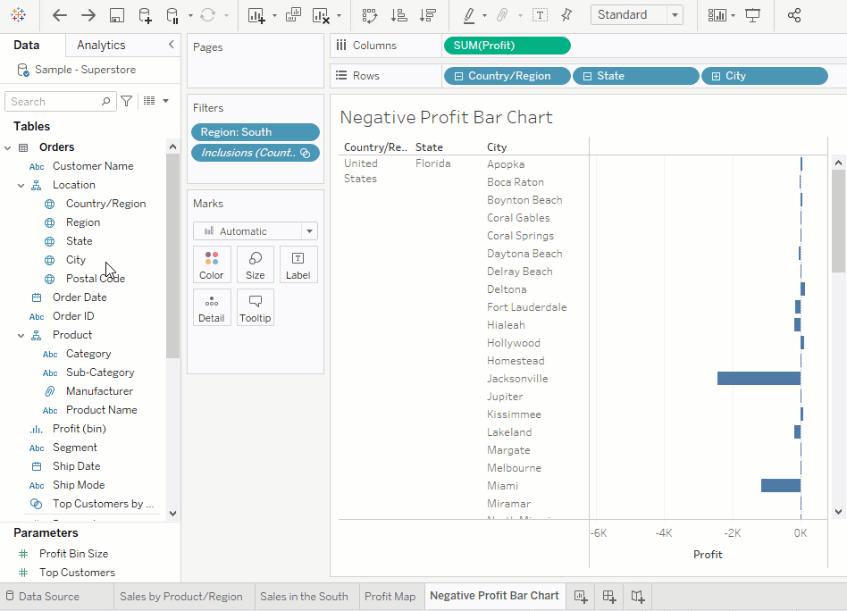
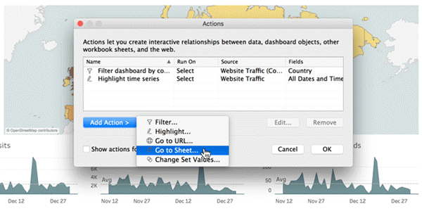
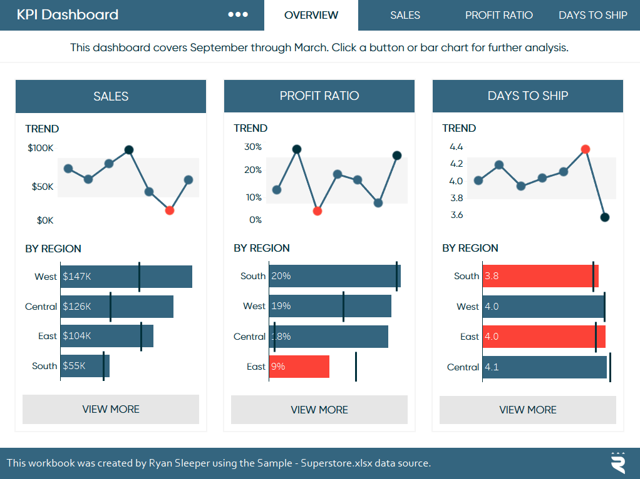
4
Drilldowns help move from summary to details.

Method 1: Filter action between dashboards
Example: Click Region on Dashboard 1 to open Dashboard 2 filtered to that region.
Steps
- Create two dashboards.
- Dashboard 1: Overview charts.
- Dashboard 2: Detailed charts.
- Go to Dashboard 1 → Dashboard → Actions.
- Add Filter action.
- Source: charts on Dashboard 1.
- Target: entire Dashboard 2.
- Choose Run action on: Select.
Result: Clicking a region in Dashboard 1 sends you to Dashboard 2 with filtered data.

Method 2: Navigation Buttons
Steps
- On a dashboard, go to Objects → Button.
- Drag button to your layout.
- In the Button Target, choose Navigate To → Other Dashboard.
- Format button text like “Open Details”.
This is clean and user-friendly.

